**Assignment #2**

Node-Red + Sensor Tag + Social (Twitter & Email)

**Assignment Description:**

In this assignment, we have created a Node-red Flow to connect to a Sensor-Tag and then display the sensor-Tag data.

The visualization also from Node-Red, we visualized the Temperature, Pressure, Humidity, and Ambient.

We used the Delay node to Share the Temperature & Pressure data to Email & Twitter after 30 Sec or any other time we set.

Below the Link to YouTube video and screenshots.

[YouTube Link] (<https://www.youtube.com/watch?v=nGs0lrtGRVo&feature=share>)

**Node-Red Flow:**

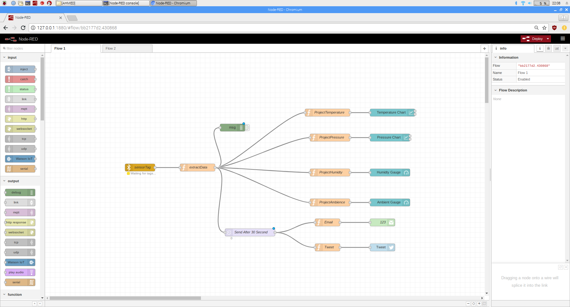

**Delay Node:**

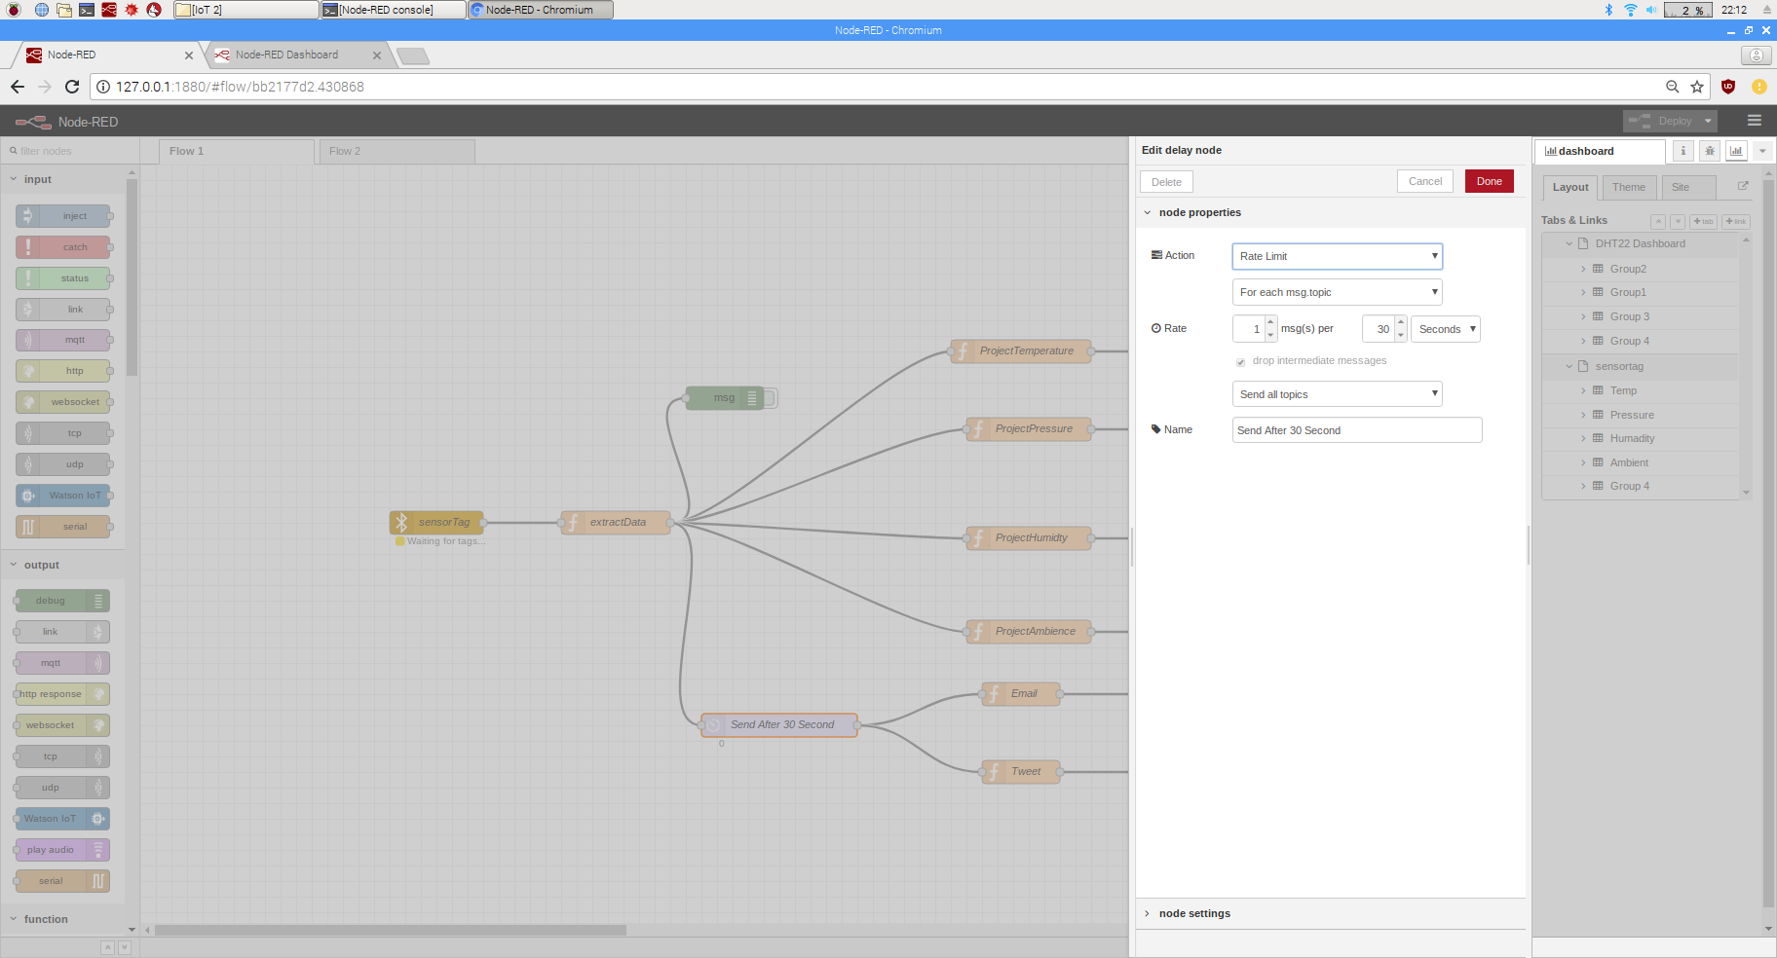

**Visualization "Temperature":**

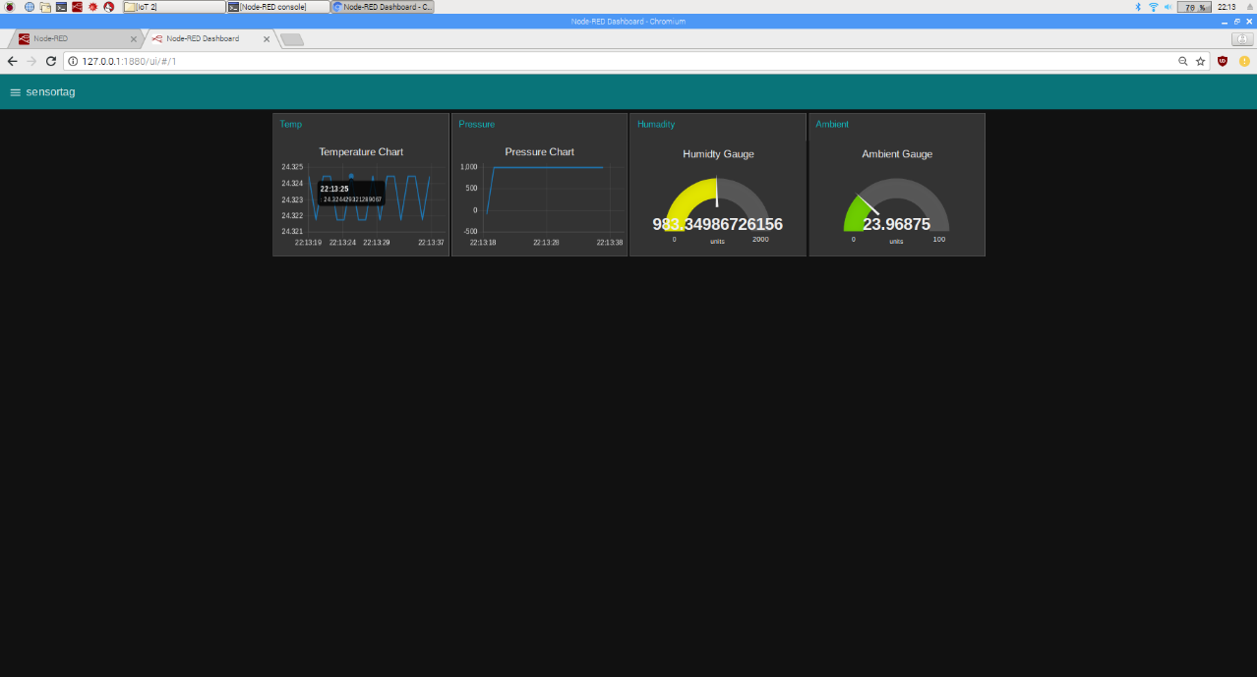

**Visualization "Pressure":**

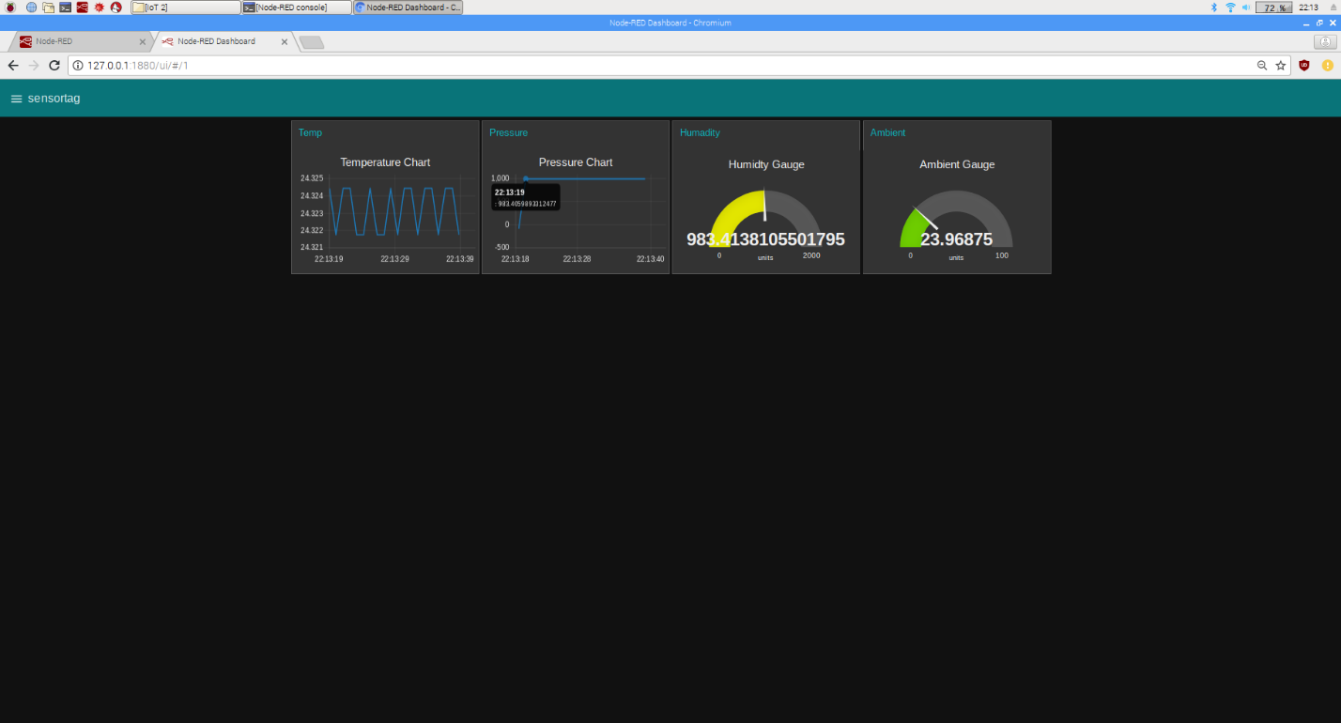

**Social "Email and Twitter":**

